Infosys Springboard Virtual Internship 6.0 Completion Report

Team Details
Batch Number :5
Start date :13 /10/2025
Names: Sanchita kumari
Internship Duration: 8 Weeks

1. Project Title
InsurAI Corporate Policy Automation and Intelligence System

2. Project Objective
The objective of this project was to design and develop a web-based insurance management portal that enables users to register, log in, view policies, book appointments, and interact seamlessly with agents. The project aimed to improve customer experience and digital accessibility.

3. Project description in detail
The project involved developing a full-stack application with React as the frontend and Spring Boot as the backend. The system provides features such as user authentication, admin approval workflow, policy management, and appointment booking. My responsibilities included implementing REST APIs, designing UI components, integrating the frontend with backend services, and testing features.
Technologies used: React, Vite, Spring Boot, MySQL, REST API, GitHub.
The solution can be used by insurance companies to manage customer interactions digitally.

4. Timeline Overview
Week | Activities Planned | Activities Completed
Week 1 | Understand the project and create login and Registration screen | Login and Registration screen created
Week 2 | Learn Springboot and implement it in the project | Started implementing Spring  Boot
Week 3 | Create User ,Admin and Agent Dashboard | User,Admin,Agent dashboard created successfully
Week 4 | Connect springboot to MySQL database | Database created and connected successfully
Week 5 | Learn to fetch data from MySQl | Successfully fetched data from database
Week 6 | Implement Agent Approval by admin | Agent approval by admin implemented
Week 7 | Implement Appointment Scheduling | User can schedule appointments with agents and Admin can approve or reject that
Week 8 | Work more on appointment scheduling and implement notification system | Notification system implemented

5a. Key Milestones
Milestone | Description | Date Achieved
Project Kickoff | Understand the project and Created login and registration screens | 27/10/25
Prototype/First Draft | Crated frontend ui and draft APIs | 5/11/25
Mid-Term Review | Project 50%complete | 17/11/25
Final Submission | Completed features delivered
Presentation

5b. Project execution details
The project was executed by dividing the tasks into backend development, frontend development, and integration. The backend APIs were built first using Spring Boot, followed by creating corresponding UI pages in React. Postman was used to validate every API. Later, the frontend was connected using fetch/axios calls. Weekly reviews ensured that tasks were completed as planned. Finally, the system was tested for functionality and user experience.

6. Snapshots / Screenshots
These are some of the snapshots and code snippets.
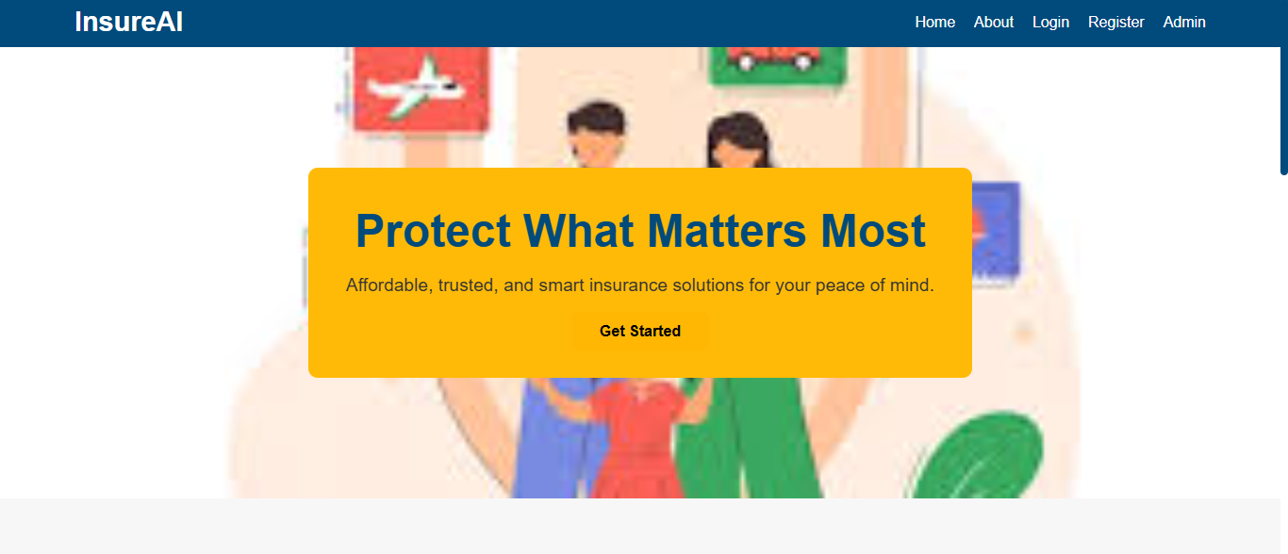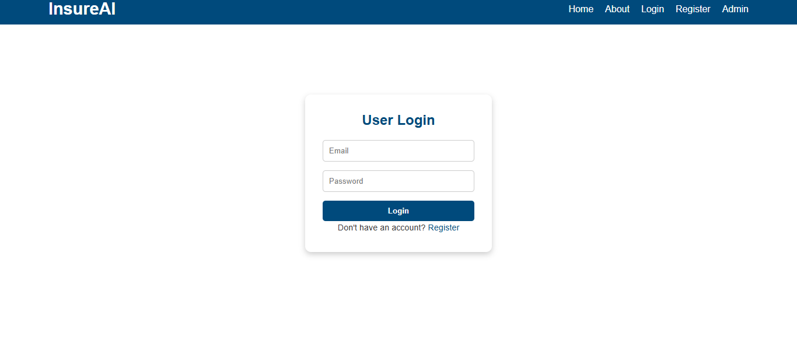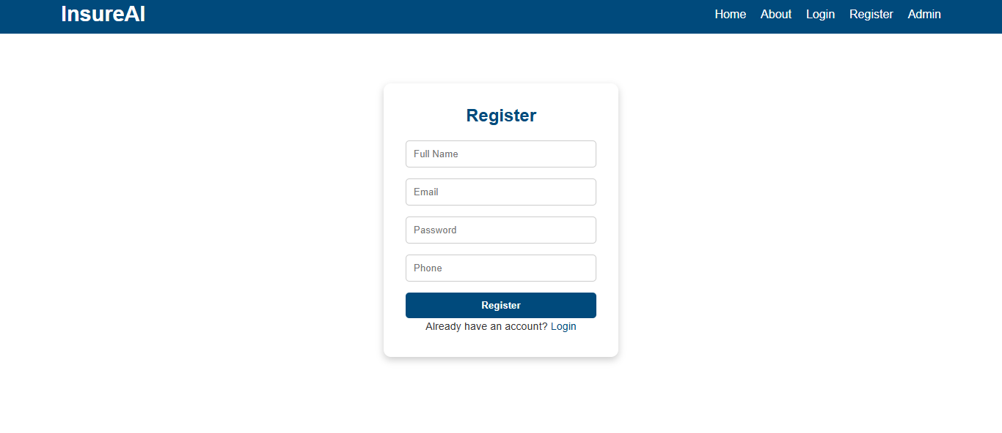

7. Challenges Faced
- Due to exams in between faced problems in managing time .
- Faced CORS and API fetching issues; resolved using Spring Security configuration.
- Difficulty integrating frontend and backend; fixed by rewriting axios/fetch functions.
- Database table constraints caused errors; corrected schema and seed data.
- Faced network issues on some day but resolved after trying re login or changing network.

8. Learnings & Skills Acquired
I learnt a lot in this internship .
- Full-stack development (React, Spring Boot, MySQL)
- Working with REST APIs and JSON
- GitHub version control
- Improved problem-solving and communication skills

9. Testimonials from team
This internship helped me gain real-world experience in building production-level applications. I learned how to structure code professionally, work with APIs, and collaborate as part of a technical team.
I was In team B all the team members are very supportive and active .Even in virtual internship whenever I have doubt they replied very quick .

10. Conclusion
Overall, the internship provided valuable learning in software development and exposed me to real industry practices. The skills and experience gained will support my future projects and career goals in full-stack development..

11. Acknowledgements
I sincerely thank Infosys Springboard for providing this opportunity. I would like to express my gratitude to my mentor who was so supportive and patient while teaching and my teammates for their constant support and guidance throughout the internship.
.

